Problem no 01:
Problem name: Addition of two matrices.
Code:
#include<stdio.h>
int main(){
int r,c,row,coloum;
int a[10][10],b[10][10],x[10][10];
printf("enter the numbers of row and coloum=");
scanf("%d %d",&row,&coloum);
printf("for mattrix A\n");
for(r=0;r<row;r++)
{
for(c=0;c<coloum;c++)
{
printf("a[%d][%d]=",r,c);
scanf("%d",&a[r][c]);
}
printf("\n");
}
printf("A= ");
for(r=0;r<row;r++)
{
for(c=0;c<coloum;c++)
{
printf("\t%d",a[r][c]);
}
printf("\n");
}
printf("enter the number of row and coloum=");
scanf("%d %d",&row,&coloum);
printf("for mattrix B\n");
for(r=0;r<row;r++)
{
for(c=0;c<coloum;c++)
{
printf("b[%d][%d]=",r,c);
scanf("%d",&b[r][c]);
}
printf("\n");
}
printf("B=");
for(r=0;r<row;r++)
{
for(c=0;c<coloum;c++)
{
printf("\t%d",b[r][c]);
}
printf("\n");
}
printf("for c mattrix\n");
for(r=0;r<row;r++)
{
for (c=0;c<coloum;c++)
{
x[r][c]=a[r][c]+b[r][c];
}
}
printf("a+b=");
for(r=0;r<row;r++)
{
for(c=0;c<coloum;c++)
{
printf("\t%d",x[r][c]);
}
printf("\n");
}
return 0;
}

Output:
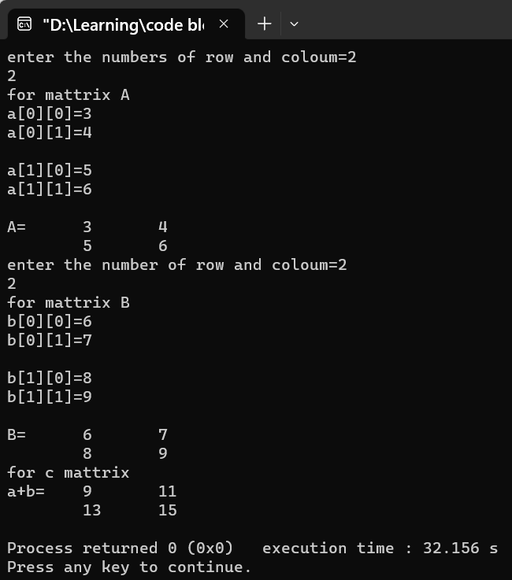

Problem no 02:
Problem name: Find even and odd number form an array and count numbers.
Code:

#include <stdio.h>
int main()
{
int arr[100];
int even[100], odd[100];

int evenCount=0, oddCount=0;
int i, size;
printf("Enter size of the array: ");
scanf("%d", &size);
printf("Enter elements in the array: ");
for(i=0; i<size; i++)
{
scanf("%d", &arr[i]);
}
printf("Elements of even array:");
for(i=0; i<size; i++)
{
if(arr[i]%2==0)
{
printf("\t%d",arr[i]);
evenCount++;
}
}
printf("\nEvrn count =%d\n",evenCount);
printf("Elements of Odd array:");
for(i=0;i<size;i++)
{
if(arr[i]%2==1)
{
printf("\t%d",arr[i]);
oddCount++;
}
}
printf("\n\nOdd count=%d",oddCount);
return 0;
}
Output:
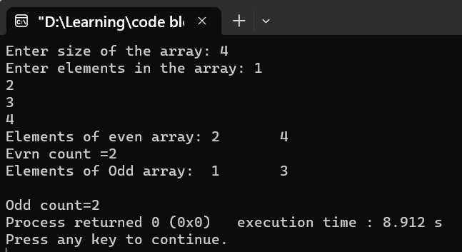

Problem no 03:
Problem name: Find negative and positive number from an array and count number.
Code:

#include <stdio.h>
int main()
{
int arr[100];
int i, N,count1=0,count2=0;
printf("Enter size of the array : ");
scanf("%d", &N);
printf("Enter elements in array : ");
for(i=0; i<N; i++)
{
scanf("%d", &arr[i]);
}
printf("\nAll negative elements in array are : ");
for(i=0; i<N; i++)
{
if(arr[i] < 0)
{
printf("%d", arr[i]);
count2++;
}
}
printf("\nCount=%d",count2);
printf("\n\nAll Positive number are:");
for(i=0;i<N;i++)
{
if(arr[i]>0)
{
printf("%d\t",arr[i]);
count1++;
}
}
printf("\nCount=%d",count1);
return 0;
}
Output:
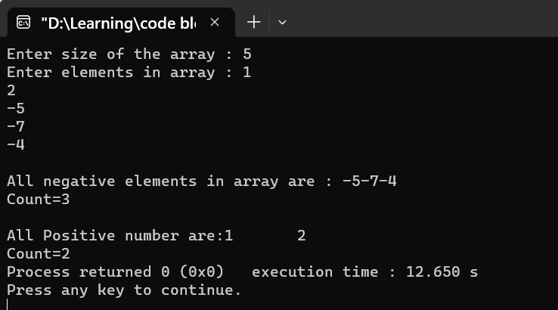
Problem no 04:
Problem name: Insert operation of an array.
Code:
#include <stdio.h>
int main()
{
int a[100];
int i, size, num, x;
printf("Enter size of the array : ");
scanf("%d", &size);
printf("Enter elements in array : ");
for(i=0; i<size; i++)
{
scanf("%d", &a[i]);
}
printf("Enter element to insert : ");
scanf("%d", &num);
printf("Enter the element position : ");
scanf("%d", &x);
if(x > size+1 || x <= 0)
{
printf("Invalid position! Please enter position between 1 to %d", size);
}
else
{
for(i=size; i>=x; i--)
{
a[i] = a[i-1];
}
a[x-1] = num;
size++;
printf("Elements after insertion : ");
for(i=0; i<size; i++)
{
printf("%d\t", a[i]);
}
}
return 0;
}
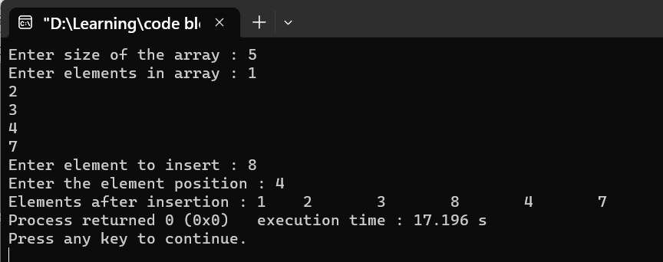

Problem no 05:
Problem name: Delete operation of an array.
Code:
#include <stdio.h>
int main()
{
int array[100];
int i, asif, n;
printf("Enter size of the array : ");
scanf("%d", &asif);
printf("Enter elements in array : ");
for(i=0; i<asif; i++)
{
scanf("%d", &array[i]);
}
printf("Enter the element position to delete : ");
scanf("%d", &n);
if(n < 0 || n > asif)
{
printf("Invalid position! Please enter position between 1 to %d", asif);
}
else
{

for(i=n-1; i<asif-1; i++)
{
array[i] = array[i + 1];
}
asif--;
printf("\nElements of array after delete : ");
for(i=0; i<asif; i++)
{
printf("%d\t", array[i]);
}
}
return 0;
}
Output:
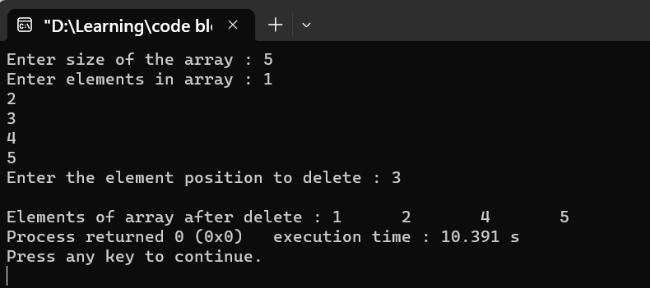

Bangladesh University of Business & Technology



Lab Report: 08
Course Title: Structured Programming Language Lab
Code: CSE-112

Submitted By | Submitted To
Name: Rakibul islam asif  ID:22235103319  Intake:51, Section:8  Department of CSE | Name: Md. Saddam Hossain.  Assistant Professor  Department of CSE BUBT

Submission Date: 29-03-2023

